Facilitating the Mental Integration of Multiple Sources of Information
in Multimedia Learning Environments
Rolf Ploetzner
Knowledge Media Research Center, Tübingen
Konrad-Adenauer-Straße 40
D-72072 Tübingen, Germany
r.ploetzner@iwm-kmrc.de
Daniel Bodemer
Knowledge Media Research Center, Tübingen
Konrad-Adenauer-Straße 40
D-72072 Tübingen, Germany
d.bodemer@iwm-kmrc.de
Inge Feuerlein
Department of Psychology, University of Freiburg
Niemensstraße 10
D-79085 Freiburg, Germany
feuerlei@psychologie.uni-freiburg.de
Abstract: If multimedia learning is to be successfull, different sources of information need to be integrated into coherent mental representations. In many cases, however, the presentation and use of different sources of information does not result in the construction of appropriate mental representations. Starting from various potentials and problems of multimedia learning, the theory of structure-mapping is proposed as a framework which can be taken advantage of to design multimedia learning environments which systematically encourage and support the mental integration of multiple sources of information. A multimedia learning environment for statistics is described which has been implemented according to the design principles proposed.

Introduction
Multimedia learning environments commonly comprise different sources of information such as various linguistic as well as static and dynamic pictorial representations. In this context, it is frequently assumed that the (simultaneous) presentation of different and possibly complementary sources of information improves learning. During the last 10 years, however, psychological and educational research have collected extensive evidence that the presentation of different sources of information in multimedia learning environments might not only not improve but even impede learning. In many cases, the „obvious“ benefits of multimedia learning environments vanish in the moment serious evaluation takes place.
In current psychological and educational theories it is hypothesized that different sources of information are processed by different mental systems (e.g., Mayer, 1997; Paivio, 1986; Schnotz & Bannert, 1999). It is proposed that linguistic information is processed by a verbal system and pictorial information is processed by a visual system. The theories differ in their assumptions about the connections between the verbal and visual system.
According to Paivio’s (1986) dual coding theory, the construction of mental representations of linguistic information only takes place in the verbal system. The construction of mental representations of pictorial information, in contrast, takes place in the visual as well as in the verbal system. Mayer (1997) assumes that mental representations constructed by the verbal system are mapped to mental representations constructed by the visual system as well as the other way round. Schnotz and Bannert (1999) propose that mental representations of linguistic and pictorial information are integrated into a single mental model which corresponds to an analogous and modality-unspecific mental structure.
According to the theories of Mayer (1997) and Schnotz and Bannert (1999), successful learning in multimedia learning environments aims at the integration of linguistic and pictorial information into coherent mental representations. However, the presentation and use of different sources of information frequently does not result in the construction of appropriate mental representations. Up until now, it has remained an open question how the construction of coherent mental representations can adequately be supported in multimedia learning.
In the following, various potentials and problems of learning with different sources of information are summarized. Afterwards, the theory of structure-mapping is proposed as a framework which can be taken advantage of to design multimedia learning environments which encourage and support the mental integration of multiple sources of information and to construct coherent mental representations. Finally, the multimedia learning environment VISUALSTAT for statistics is described. This learning environment has been implemented according to the design principles proposed.

Potentials and Problems of Learning with Multiple Sources of Information
Potentially, multiple sources of information may improve learning in multimedia learning environments in various ways. For instance, different sources of information may be complementary, resulting in the construction of more complete mental representations of an application domain than a single source of information (e.g., Ainsworth, 1999). Furthermore, multiple sources of information may realize different conceptual perspectives on an application domain leading to the construction of multiple mental representations which can flexibly be used during problem solving, for example (e.g., Spiro & Jehng, 1990).
During the last 10 years, however, psychological as well as educational research demonstrated that the presentation of different sources of information in multimedia learning environments poses various problems to the students. Each source of information may rely on notations which are not familiar to the students. For instance, in many cases students are not able to identify visual and spatial structures in pictorial representations which would allow them to understand an application domain (e.g., Lowe, 1998). In other cases, students do not interpret the perceived visual and spatial structures conceptually (e.g., Weidenmann, 1994). Very often, such a lack of visual literacy is accompanied with illusions of understanding (e.g., Salomon, 1994).
The need to process different sources of information poses additional challenges to the students. For example, the students have to process larger amounts of information and to direct their attention simultaneously to different information (e.g., Lowe, 1998). Very often, these requirements overburden the students’ cognitive capabilities resulting in only little learning (e.g., Sweller, 1993, 1994).
One of the most severe problems, however, may be the finding that students frequently do not systematically relate different sources of information to each other (e.g., Ainsworth, Bibby & Wood, 1996; Anzai, 1991; Kozma et al., 1996; Lowe, 1998; Peeck, 1993). As a consequence, these students fail to integrate the information into coherent mental representations. Their mental representations about an application domain remain fragmentary and - especially - disjointed. During problem solving, for instance, these students very often switch back and forth between different mental representations of a posed problem without being able to determine which representation contributes in which ways to the problem’s solution (e.g., Anzai, 1991).
Although the use of multiple sources of information has the potential to deepen understanding, their coordination and integration does not take place on its own.

Facilitating the Integration of Multiple Sources of Information by Structure Mapping
We propose the theory of structure-mapping as a framework which can be taken advantage of to design multimedia learning environments which encourage and support the mental integration of different sources of information. Initially, Gentner (1983) modeled the construction of analogies between two application domains by means of structure-mapping. A structure is made up of objects and their attributes as well as relations between objects. According to Gentner’s (1983) model, an analogy is constructed by (partially) mapping the mental structure which represents the familiar domain, named the base, onto the mental structure which represents the unfamiliar domain, named the target. In recent years, Gentner and Markman (1997) demonstrated how structure-mapping can be used to model how similarities among different objects are established.
We apply the model of structure-mapping as a means in order to encourage and support students to (1) externally relate different sources of information to each other and - as a consequence - to (2) mentally integrate the different sources of information. In many cases, different sources of information in multimedia learning environments delineate structures which are (partially) related to each other. Because students rarely identify relevant structures and establish relations between them spontaneously, the model of structure-mapping can serve as a framework in order to guide the implementation of mechanisms into a multimedia learning environment which interactively and systematically (1) encourage the identification of structures relevant to an application domain and (2) support the construction of relations between the identified structures by (partially) mapping one structure onto the other.
In earlier research it has been demonstrated that students who actively relate different sources of information to each other construct more complete and more coherent mental representations of the application domain under scrutiny than students who do not (e.g., White, 1993). To know the relations between different sources of information also allows one to flexibly switch between them on the one hand and to integratively make use of them on the other hand during problem solving, for example (e.g., Anzai, 1991). Structure-mapping forms one means to guide the construction of such relations.

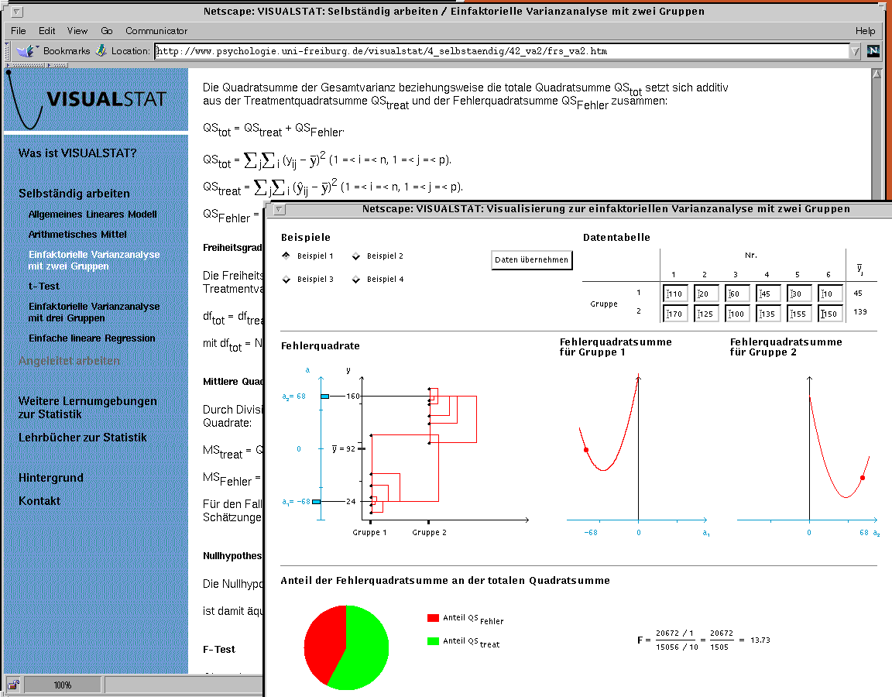

Figure 1. Different sources of information about the model and the methods underlying the one-way analysis of variance with two groups.

Supporting the Integration of Multiple Sources of Information in VISUALSTAT
VISUALSTAT is a multimedia learning environment for statistics for the social sciences in the World Wide Web (www.psychologie.uni-freiburg.de/visualstat/). It comprises different sources of information about various models and methods of statistics such as the general linear model, the method of least squares and the partition of the sum of squares. These models and methods underlie frequently applied procedures in statistics such as the t-test, the (one-way) analysis of variance and the (simple) linear regression (e.g., Hays, 1994). VISUALSTAT does not make up a complete and self-contained learning environment which is intended to be used instead of a textbook. It rather complements a textbook. While textbooks describe the considered models and methods almost always exclusively by means of text and algebraic equations, VISUALSTAT additionally visualizes them dynamically and interactively (see Figure 1). The dynamic and interactive visualizations draw a student’s attention to properties of the considered models and methods which frequently remain unrecognized or misunderstood in traditional statistics courses.
VISUALSTAT can be used in two different modes: (1) self-guided and (2) guided learning. The mode of self-guided learning aims at students who are already familiar with the dynamic and interactive visualizations in VISUALSTAT. These students are encouraged to take advantage of the different sources of information according to their own learning objectives and information needs.
The mode of guided learning aims at students who are unfamiliar with the dynamic and interactive visualizations. These students receive guidance according to the design principles described above. Firstly, in order to avoid cognitive overload, one visualization after the other is presented to the students.
Secondly, the students are encouraged to interactively and systematically map step by step components of the (familiar) textual and algebraic representations to components of the (unfamiliar) graphical representations in order to learn (see Figure 2): (1) which components make up the visualizations, (2) how the text, the algebraic equations and the visualizations are related to each other as well as (3) how the different visualizations are related to each other.
Every time a mapping is completed, the students are informed about the correctness of their mapping. If students repeatedly construct an incorrect mapping, the correct one is explained to them.

Figure 2. Interactive mapping of components of textual and algebraic representations to components of graphical representations underlying the mean.

Discussion
Although multimedia learning environments potentially may improve students’ learning in various ways, they also may impede learning. For instance, students frequently do not systematically relate different sources of information to each other in multimedia learning. As a consequence, their mental representations about an application domain remain fragmentary and disjointed.
In empirical studies which revealed these problems it is very often concluded that learning in multimedia learning environments needs to be supported (e.g., Ainsworth, Wood & Bibby, 1996; Peeck, 1993). However, until now, only a few measures have been proposed to support multimedia learning (e.g., Mayer, 1997; Sweller, 1993, 1994). The measures which have been proposed keep the students in perceptive and rather passive roles. They focus on how different sources of information should be presented to the students in oder to facilitate the students’ learning (e.g., Mayer, 1997; Sweller, 1993, 1994).
In this paper, we proposed a form of support which places the students in active roles. It focuses on how the students’ mental processing of the presented information can systematically be encouraged and supported. Our proposal was based on the theory of structure-mapping (cf. Gentner, 1993). According this theory, two sources of information can be related to each other by (partially) mapping structures from one source of information onto structures in another source of information.
The multimedia environment VISUALSTAT was equipped with mechanisms which implement the proposed principles. In VISUALSTAT, the students are guided to relate different sources of information to each other by (1) identifying the relevant structures in the information presented and (2) constructing mappings between the identified structures. We are convinced that the activity of systematically relating different sources of information to each other will result in the construction of more complete and more coherent mental representations. Currently, we are designing an experimental study which will be conducted in order to formally evaluate the learning effects of the support mechanisms implemented in VISUALSTAT.

Acknowledgment
This research took place within the Virtual University in the Upper Rhine Valley (VIROR; www.viror.de) and was supported by the state of Baden-Württemberg.

References
Ainsworth, S. (1999). The functions of multiple representations. Computers and Education, 33, 131-152.
Ainsworth, S., Bibby, P. & Wood, D. (1996). Co-ordinating multiple representations in computer based learning environments. In P. Brna, A. Paiva & J. Self (Eds.), Proceedings of the European Conference on Artificial Intelligence in Education (pp. 336-342). Lisbon: Colibri.
Anzai, Y. (1991). Learning and use of representations for physics expertise. In K. A. Ericsson & J. Smith (Eds.), Towards a general theory of expertise (pp. 64-92). Cambridge: Cambridge University Press.
Gentner, D. (1983). Stucture-mapping: A theoretical framework for analogy. Cognitive Science, 7, 155-170.
Gentner, D. & Markman, A. B. (1997). Structure mapping in analogy and similarity. American Psychologist, 52, 45-56.
Hays, W. L. (1994). Statistics (5th ed.). Fort Worth, TX: Harcourt Brace College Publishers.
Kozma, R. B., Russell, J., Jones, T., Marx, N. & Davis, J. (1996). The use of multiple, linked representations to facilitate science understanding. In S. Vosniadou, E. De Corte et al. (Eds.), International perspectives on the design of technology-supported learning environments (pp. 41-60). Mahwah, NJ: Lawrence Erlbaum Associates.
Lowe, R. K. (1998). Verarbeitungsanforderungen beim Verstehen komplexer animierter Bilder [Processing challenges of understanding complex animated pictures]. Zeitschrift für Pädagogische Psychologie, 12, 125- 134.
Mayer, R. E. (1997). Multimedia learning: Are we asking the right questions? Educational Psychologist, 32, 1-19.
Paivio, A. (1986). Mental representations: A dual coding approach. New York, NY: Oxford University Press.
Peeck, J. (1993). Increasing picture effects in learning from illustrated text. Learning and Instruction, 3, 227-238.
Salomon, G. (1994). Interaction of media, cognition, and learning. Hillsdale, NJ: Lawrence Erlbaum Associates.
Schnotz, W. & Bannert, M. (1999). Einflüsse der Visualisierungsform auf die Konstruktion mentaler Modelle beim Text- und Bildverstehen [Influence of the type of visualization on the construction of mental models during picture and text comprehension]. Zeitschrift für Experimentelle Psychologie, 46, 217-236.
Spiro, R. J. & Jehng, J.-C. (1990). Cognitive flexibility and hypertext: Theory and technology for the nonlinear and multidimensional traversal of complex subject matter. In D. Nix & R. Spiro (Eds.), Cognition, education, and multimedia: Exploring ideas in high technology (pp. 163-205). Hillsdale, NJ: Lawrence Erlbaum Associates.
Sweller, J. (1993). Some cognitive processes and their consequences for the organisation and presentation of information. Australian Journal of Psychology, 45, 1-8.
Sweller, J. (1994). Cognitive load theory, learning difficulty, and instructional design. Learning and Instruction, 4, 295-312.
Weidenmann, B. (1994). Lernen mit Bildmedien [Learning with pictorial media] (2. Aufl.). Weinheim: Beltz Verlag.
White, B. Y. (1993). ThinkerTools: Causal models, conceptual change, and science education. Cognition and Instruction, 10, 1-100.

